Chapter 5 – Bands
And now the Van Stories:
We were coming back from a gig, across Dartmoor, in the very early days with our yellow Commer van. We were stopped by the police that there were escaped prisoners on the loose and told us to have a good look for them on the moor but do not approach them as they were dangerous.
Just a couple minutes later there was a huge bang and the van filled up with smoke. We thought we had been shot! Humphrey was into shooting and it sound it sounded like a 12 bore.
We shit ourselves and hurried off the moor, so we could have a good look at the damage. We were all outside for pellet holes or dents.
We found nothing but when someone noticed that the spare, which was stored behind the driver’s seat, was split.
I had exploded, and the “smoke” was dust from the dirty tyre.
The engine of the yellow Commer started to knock. In those days we dreaded the sound of a “big end” knocking. We were advised not to drive it anyone until the engine was stripped and the big end shells replaced.
We ignored the advice and within a couple days coming back from a gig in Torquay there was a big bang and it stopped. I opened the bonnet and the engine was glowing red but there was a big black area. That was the hole where the crankshaft had popped through.
A mate of ours, Jim Callahan, managed to find a Perkins diesel and he implanted it into the Commer.
The next van was a Morris J2. Bud and I painted it psychedelic on the site of the Applied Science Block – by my site office at work. Gary Kane was carpenter on this site.
We then had to change the colour of the van in the log book – at the car taxation office in Little Caste Street, Exeter. The clerk could not spell psychedelic, so he recorded it as “multi coloured”!
We put a sign in the back of this one – “Do Not Laugh - Your Daughter Might Be Inside!” A similar sign was used in the next couple vans.
This J2 was just a wreck. The kingpins had virtually seized so it was almost impossible as it made the steering tight. We also had to pump the brakes to stop it.
We were off to Stratton near Bude and on route we met a lorry under a narrow bridge and we could not stop and rammed into the lorry. We were Ok bit the front was bent. As this a column change it buckled some of the linkage and we only had a couple gears but no reverse.
We limped to Stratton, borrowed a lump hammer and straightened out the linkage so that we could now find all the gears.
Two days later we were at Butlins.
This van died a couple weeks later with a heart attack - big end decease!
Our next was our blue Commer. We were driving through Ilminster or Ilchester and I had to make an emergency stop. One of the front brakes grabbed, it sent us into the kerb and the van tipped over on its side.
Within seconds there were loads of people around. We scrambled up through the passengers sliding door. There were loads of hands on deck to tip the van upright.
We were OK but the drivers sliding door was off its runners, the front offside wheel now had a camber and our orange, green and yellow stage suits were ruined by the acid from the battery.
We filled up the van with petrol, oil, water and topped up the battery and off to Nottingham.
From that day until it died our blue Commer van still had the camber on the front wheel and the door was held in place by a fan belt and we used the passenger door.
Our next hiccup with this one was right in the middle of Brussels when the throttle cable snapped. For the rest of the journey to Germany I needed a co-pilot to work the accelerator and shout on every gear change!
Driving through Stuttgart on day we were stuck in traffic next to a big white Merc. The driver knew we were English, by our number plates, and wound down his window and spat at the van. Unfortunately for him I was eating chocolate, so I planted a big brown one on his bonnet!
This one died in Germany.
Our faithful VW went around the clock one and a half times (in Km) and had two engines – they were only 1200cc, so they really had to work hard.
In Furth we got pulled by the police for having a noisy exhaust – “Die auspuff est kaput”. We were cautioned, given some paperwork and told to get it fixed within fourteen days. We never bothered but by complete chance the same coppers stopped us about a month later. We were then taken to the police station and they jacked the van up to do a thorough check of it.
It seems corny now, but we were very frightened as they always carried guns. Our worry was that the horn did not work but fortunately this was not check. This time we got the “auspuff” fixed!
We were in Paris, loaded up and just filled up with oil, water and then bang – yet another 1200cc failure. We did not even get out the forecourt. A couple of us hitched a lift back into Paris and hire a van. We transferred all our belonging and left the VW behind.
Our hire van was costing us a lot of money and we really needed a right hooker (right hand drive) van.
Somehow Lionel Digby (our agent in Torquay – LMD Entertainments) found us a Ford Thames, for sale, in Totnes so someone had to come back to the UK and bring it back to Paris – I did it.
Saturday night we had a gig, in Paris, until five in the morning. We decided to pack up the kit and shoot straight off to out next gig near or in Lille – Arras rings a bell.
We got up there set up and we had an afternoon and evening spots. These were forty-five minutes on and fifteen off and literally catching an odd five- or ten-minutes doze in between.
When the night was over Bud took me to the station in Lille and caught a train into London, tube across London to Paddington and then by train to Totnes. I think Lionel met me from the station to where the van was.
I got lost on the underground in London! After all our travelling on the Metro we never got lost as if you changed line you changed levels.
On the underground circle line in London you must read which train to get on – of course I got on the wrong one!
Anyway, driving back from Totnes, I stopped on the by-pass in Exeter and phoned Mum and told her to get the frying pan on.
Mum panicked – “what are you doing home?”, “What has gone wrong?” and “where are the other three?”
When I got back to Exmouth, I told Mum what I was up to. Mum fed me up and I was off to Dover. In those days it could take as long as twelve hours to get there. I eventually got back to Paris Wednesday late morning.
The last night in bed was the previous Friday – I was knackered. I feel out with Tommy over something so small and a chucked a glass of water over him and I think Bud had to separate us. Anyway, after a good kip we were all OK again.
Our longest trip was driving from Paris down to Rome. It took us thirty-three hours solid and only stopping to eat and fill up the van. I drove for twenty-six hours of it. When I got tired, I laid in the back, had a snooze and back to the wheel.
There were four main memories of the journey.
Driving through Monte Carlo was something else - looking back we should have stopped for a while to savour it.
We were getting paid for this! – seeing all these wonder sights on our tours in Europe.
The cars fascinated me in Europe as they were all unique to their country. Every other car in France was a Renault 4 or Citroen 2CV, in Germans the Beetles were everywhere and even if you saw a Ford in Germany it was badged as a Ford Taunus – a Cortina with a different grill and rear lights. In Italy I used to trip over the Fiat 500s!
When we got in Fiat land and stumbled across a brand-new motorway just opened. This road went right through the mountains – one minute we were on a very high viaduct and then into a long tunnel. This was an amazing engineering feat. I think this was around the area Genova.
The fourth main memory of the journey was our recently acquired Ford Thames was getting a bit poorly – the valves were burning out and losing power drastically. We came to one hill and it would not go up it, so we had to reverse up as reverse gear was lower than first.
We just made it to Rome and it would not go any further. During the next two weeks a garage managed to get a new set of valves and we were alright to get back to Paris
Out first Transit was inherited from Trevor (Inch) after Contraband.
This started life as a diesel but was converted to a V6 petrol - it went like hell but gobbled petrol. It eventually caught fire on the M4 - ironically returning from gig at Cinderford on 03/02/79. All the equipment was saved but the only item lost was John's leather coat - he only found the hook of the hanger.
We were coming back from a job in North Devon on not very good roads. It was Mike (Evershed)’s turn to drive. The roadies had loaded the equipment and us, Mike put the van in reverse and the gearstick came away in his hand. We had a bit of a tool kit, but we could not suss how to put it back together, so we had to use a big screwdriver and poke it in the hole to select the next gear.
We looked at it the next day and it popped straight back in!
I had three convictions related to the van driving days:
The first one was when I was on my own and I had just dropped the rest, about 3:00am, and driving up Cowick Street to turn right into Buddle Lane. As I turned a police car came from my left from Cowick Lane. To this day I swear the police car went through the red lights and I was on green – I got booked and fined.
I had two fines for no tax – both bad lucks.
The first time we literally got back, in the country, from the second tour of Germany – five months. The tax had expired but I argued with the policeman that we had got home and proved it by showing the stamp on my passport. He told me that we should have taxed it before we came home – booked and fined!
The other time was at Butlins. Our J2 had died and the replacement, the blue Commer, was found in Axminster. The plan was to buy it, get all the paperwork and drive, in Cliff’s car, back into Exeter to tax it.
We were running out of time, so we took a chance to drive the van into Exeter, tax it and then go straight on to Minehead – we got stopped. Yet again I had a discussion with a copper. I proved by showing our contract to him and that it would have been quicker to get to Minehead from Axminster rather than via Exeter – no good booked and fined again!
From those days I never drove a vehicle untaxed!
One New Year’s Eve we were booked to play at Minehead Social Club and it was chucking down loads of snow. The booker phoned us a couple times to test the weather each end and if we all needed to cancel the gig. We told them in Minehead that we would somehow get there – the police, AA etc said we would not.
We set out just after lunch loaded up with shovels and sacks. We filled up at Granada Services in Exeter, but we could not pull away, so everybody had to get out and push. We then drove around the corner to the M5 and it was coned off. We removed a couple cones and we were off!
The M5 was fine – then off junction 26 through onto the A38 at Wellington and near Taunton head off to Bishops Lydeard, Williton and Minehead. We got through but thanks to the snow ploughs as the snow was very deep on the last stretch as it looked like the Cresta Run. We had to jump up and down on the bumper on some of the hills, but no real problems and we got there about 5:00pm and the booker well pleased.
We had a good night and set off for home. We had to do the “jumping on the bumpers” routine and of course the lager had set in and Bud was prone to fall off the back. He soon learnt that if he lay on his back his coat acted as a sledge and then hold onto the bumpers.
This was great, and we all had a crack at that – the problem was that being towed on you back at over 20mph occasionally there were gaps in the snow where it had not laid or thawed. You then stopped suddenly and the choice is either let go and be left behind or hand on, if you have not already had your arms ripped off, or wear out the coat and subsequently end up with a very sore and damaged back – it was always wise to let go and hopefully the roadie would reverse back to pick us up!
We were heavily into pyrotechnics especially with Bud and I setting fire to things and Rod with his exploding stage props – Gary was always frightened of the exploding hoover when rigged up by Rod.
One of the party tricks was setting fire to the waste paper bins in the lay-bys coming back from Plymouth on the A38. We used to stop for a pee and within seconds Bud would have a bin on fire. We then drove to the next one to see if we could see the flames in the distance of the previous one and then set fire to this one and move to the next. As far as I know we never damaged anything or anybody!
Unfortunately, one of the pranks backfired ironically returning from a gig at Cinderford. We were on the M4 and Bud decided he was cold and to keep warm set fire to a newspaper. The fire got out of hand and flames got behind the dashboard. We were always well stocked with lager and we shook them up and sprayed it into the dash, but we could not put out the fire. We decided to abandon ship.
As usual Gary was like a headless chicken and worried about the petrol tank exploding. We all worked like hell and got all the kit onto the hard shoulder and saved everything except my posh leather jacket and strides. I found later that all was left was the hook of the hanger of my clothes. We did get Gary’s drum kit but not helped by him!
The police and fire brigade were quick attending and transport for us and the contacts was arranged and the disposal of the body. A company from Bristol came out to take us the Exmouth and my last memories of our faithful Transit was seeing it loaded on the lorry and it had to go down the motorway to cross over and get it back to Aust Services. I watched it both ways and the shell was still licking out flames and sparks flying everywhere!
I think some of our stage clothes were damaged and the mike stands developed the blue tint after a fire. The next day, knackered and no stage clothes, we had to do a “Showcase” at a hotel in Kennford.
Another incident with fire was coming home one night and we found a hot dog stand just outside Axminster. We all piled in and ordered our burgers and waited. Someone, it might have been Mike (Evershed) – affectionately as “Grub Shed”, was reading his paper and I sat fire to it. The owner was not too happy and banned the Graded Grains for life from his “restaurant”. We went home hungry!
Come to think of, I was personally banned from “Mummies” hot dog stand at Goldsmith Street and later outside British Home Stores. In “high spirits” I sprayed the van with ketchup. For a long time, I had to hide in the Tranny and the others had to get my food. I was forgiven after a couple years!
Once coming down the M5 we called into Taunton Deane Services. The service was crap. We collected all the food and queued up to pay. No one was interested in our money, so we sat down and had our grub. We looked around to pay and they were still not interested so we legged it.
A few minutes later blue lights and siren bearing down on us but went past and later nearer Exmouth the police homed on us again and went past – we got away with it and it seems them right!
I used to, and still, begrudged the price of the food at the service stations. I profess to be an honest chap but if I can put one over these crooks I will. I used to enjoy a good breakfast after a gig and on many occasions at the Granada Services at Exeter. I used to hide a couple extra sausages under the plate with my fingers, so I only paid for the food on top of the plate. Sausages were easy to pinch but a bit more difficult with a fried egg or baked beans!
One of Rod’s party tricks was to climb out of the van as we went along.
We had finished a gig in Lyme Regis and just up the road there was a smart, tidy guy and hitching. We pulled up and asked where he was off to and he replied Exeter. He climbed aboard and told us that he had been playing cricket and the coach had left without him.
We went along and just chatted. With that Rod climbed out the side window and we heard him crawling along the roof. All he had to hold onto was the guttering or our “Fred” on the roof.
These two happened exactly at the same time. I asked this guy what he did for a living and Rod was now looking in upside down at this guy who was telling me he was a police officer!
Nothing was said, and we dropped him off at Middlemoor. I wonder what he thought of us lot?
This ritual went on many times but one night on the Barnstaple to Exeter road Bud was climbing out the passenger’s door one night and the door swung back and badly damaged his left-hand fingers. He had to play with only two or three fingers for several gigs.
Talking about this road even as a child we always saw a weird guy with a hood on walking the road around Umberleigh. He was known as “The Hooded Tramp”, “Umberleigh Jack” of “Black Jack” – no doubt there were many more names.
I think he was still around in the late seventies or possibly the early eighties. We always saw him coming home from gigs and he could have been sighted as far up past Umberleigh and almost as far down as the old Fortescue Arms.
Of course, the locals knew what to expect on the road but if any tourist saw him in the early hours, they probably thought it was a ghost!
There were many stories about him, but the general conception was that he was that he was a very clever man but went over the edge and struggled with being cooped up. Apparently, he composed the crosswords for the Guardian or Times. There was never a chain on his push bike which in the earlier years always had it. He and his wife lived in the open or in the two Austin A30/A35 cars which at some stage were parked somewhere in the facility. They in the late sixties/early seventies had a caravan which seemed to be their home.

And now the Band stories:
The very first gig was at Mount Pleasant Youth Club, Exeter. I remember it well as I could not play chords – I played the melody! This hall & the church next door are now a block of flats.
The first public gig was at the Holiday Inn, Dawlish Warren – now the Welcome Inn.
And the first paid gig was Victory Hall, Exminster which the band was paid £5.
I will look through the gigs from the start until the professional era and pick up the odd story - but not in any order.
Just looking through we played with a few “named” bands:
Sounds Incorporated x 2, Honeycombs, Heinz, Four Pennies, Brian Poole & the Tremolos, Who and the Pretty Things.
A complete chance as Sounds Incorporated had a track called “The Spartans”.
Late 1964/early 1965 we played weekly at the Winkleigh Hotel, Winkleigh & passed the hat around – sometimes we got nothing & the maximum recorded earnings was £2.10.
An early Spartan story was when we were on our way home from a booking at the Sgts Mess, RAF St Mawgan.
Approaching the A30 we decided to have a pee. It was pitch black and the next minute we heard a little cry for help! – Chris was missing. We got out our lighters and I saw the reflection of Chris’s glasses way down in a ditch.
We dragged him out and he stank! As he smelt so much, he was confined to the back of the van for the rest of the very cold journey.
We thought we were in for trouble on 4th November. Advertises at the Queens Hall, Barnstaple tonight was The Who, Variations and us. The Variations opted out as they were promoting their first release “The Man With All The Toys” – hopefully a Christmas hit.
We started the show but the Who had not turned up. Everybody panicked but hoped that there were just delayed. They did not show up so all there is left is us!
The iron safety curtain was lowered, and all the punters thought that the stage was being prepared for the Who. The announcement was then made that the Who had not turned up - there was a huge sign.
The next announcement was that the Spartans would play for the rest of the night.
The iron curtain was raised and instead getting abuse, there was a huge cheer and it ended up as a brilliant night – we played our hearts out!
This was filmed, in colour, by Brian Roberts and it might be still around, but we only ever viewed it once.
One of the Spartans claim to fame was on 24th December 1966 when we topped the bill at the Flamingo Club in Redruth. We wore multi coloured trousers. One leg of mine was pink at the front and yellow at the back and the other leg was vice versa.
When the curtains opened the girls screamed – this did not happen very often!
The support band was the “Reaction”. The drummer, in a blue suit, fronted the band which was very unusual. He really was in control - we found out later that it was Roger Taylor who later joined Queen.
In May 1967 we went for an audition with Track Record - part of the Polydor group. This was at the Why Not in Oxford Street, London. The main artistes on the Track label were the Who, Cream & Hendrix.
All we played were “copies” but all they were interested in was our compositions. All we had at that stage was a half written “Animal Magic” which did not impress the big knobs from Polydor – we were not used!
A lady was looking after the club/rehearsing rooms and told us that Hendrix spent a lot of time there practising on his own without Mitch Mitchell and Noel Redding. He used to take his stacks of Marshall amps and play all full blast developing his sounds.
Prior to us getting the contract at Butlins the local bands used to take a week off their day jobs and work at the Rock Ballroom for that week.
Butlins paid the bands £60 for the week. Most of the bands were four or five piece. We found out that minimum musician union rate was £20 a week so Butlins were breaking the rules. At this stage we were a three piece so we fitted perfectly into the MU rate.
Butlins would not give us chalets so we lived in the van in the car park outside the camp. We had to be off the camp by midnight and not allowed back in until midday. We all then went to the shower blocks for our ablutions.
We think the lack of privileges was because the other staff were so poorly paid, compared to the musicians, and possibly begrudged our fee. We did though have “concessionaire” food in one of the cafes.
We used to go home after finishing Monday nights. Our Mums used to feed us up, wash and iron our clothes and back again for Wednesday night.
The male redcoats were only paid £7 and the girls £5.
We made a lot of friends at Butlins and I shall a guy, name forgotten but lived at Castle Cary, worked in the kitchens and he supplied us with pie or the like and we used to find it in the changing room of the Rock Ballroom.
We met two girls from Nottingham. My “girlfriend” was called Lesley (Cummins) – she was 4’11”. After the holiday they jumped on their scooters and came down to Minehead to see us. The four of us, Bud being the forth, kipped on the beach – Cliff had the van to himself.
We drove up to Nottingham a couple times, sleep in the van, cleaned up in the underground toilets and breakfast in Joe Lyons opposite.
After Butlins we had two or three auditions to find some work abroad and we soon acquired a six-month touring the EM (Enlisted Men) Clubs in the American bases in Germany.
Part of the deal was that we needed a girl singer. Lesley (Ireland) was one of the local singers with the Maurice Price Band at Tiffany’s, Exeter.
A guy called John Hiley-Payne managed Lesley. John H-P would allow us to take Lesley to Germany and long as he would take over as manager of the Graded Grains – so now we have a girl singer and a manager. On top of this, with the deal, we inherited a roadie called Togg as a chaperon to Lesley.
This was strange as he was always in his suit driving his own car – a Ford Consul Capri and we all travelled in the van. He never even drove the van and was not even there at the teething problems at the start of the tour.
His only role was to put the guitars and mikes away at the end of the night and once a month go on ahead to find our hotel.
I believe he went home after a couple months.
We are now nineteen years old, professional with a huge world in front of us. No more relying on our Mums to feed us, wash our clothes and no more subbing a fiver!
Looking back, we were so green and not prepared for this adventure. Our blue Commer was a wreck and very little money – all we had was our wits.
All we needed was £20 to get to Germany for the petrol and ferry and this left a few quid in our pockets.
Somehow, we got confused with Lugwigsburg and Ludwigshafen. We started off at Ludwigshafen Kaserne (Barracks). This was the wrong place so down to Ludwigsburg.
We were to play for ten days in each of the three Kasernes in the town – Coffey, Flak & Krabbenlock. We went to all three and there was a band set up. We phoned our agent (name gone at the moment) and he assure us that one of the other bans were at the wrong venue. We thought that this perhaps was our shortest tour of Germany.
The next day it was all sorted out.
In the meantime, we learnt that a lot of the bands stayed at a Pension (just a room) opposite the station. We wandered around but there were no signs of any rooms. I walked around again and saw some graffiti – “Fatty is a c**t”. I looked up and saw a groupie looking guy peering at me looking like Chad. This was our room for the month or should have been.
All four, including Lesley, were in the same room. A big basic space and this was our first experience of duvets? – we wondered how this lot worked! – with no sheets, blankets and eiderdown!
After a week or so Lesley’s bed collapsed. Big fat Fritz – the owner of the Pension accused me of breaking her bed and we were evicted.
Lesley and I moved to another room nearer the clubs.
This was close to the band splitting up – the rule was that we were not to get involved with Lesley and it was tense for a while. It was Lesley and I against Bud and Cliff. However, we got through it.
Our first month apart from the personal side was a great learning curve and the yanks were so gullible.
We built up a large repertoire of about 250 songs and took great notice of what material they liked – from country to Hendrix.
The next month, November, we were at Nelligen, near Esslingen not far from Stuttgart.
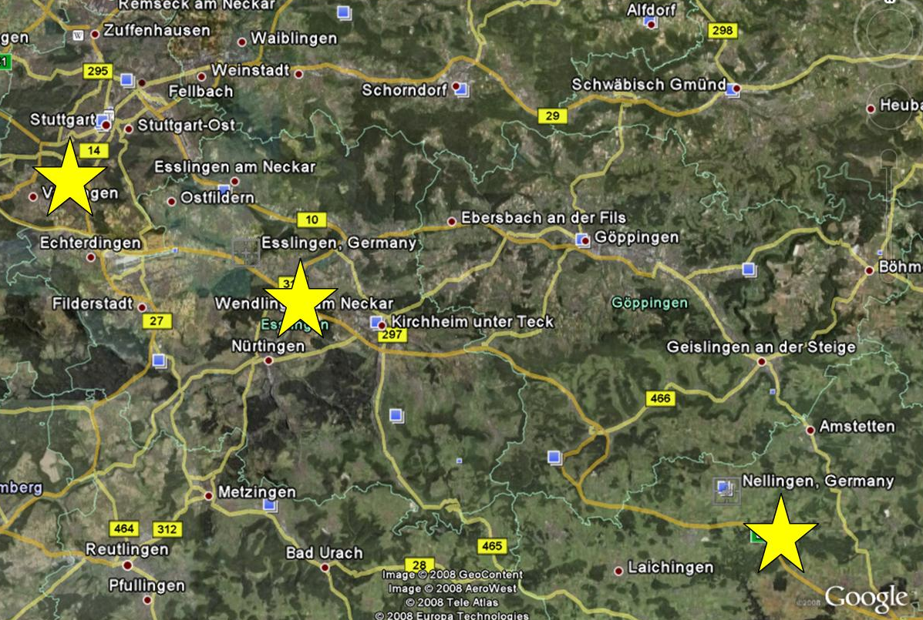
It was great here. The club, the town of Esslingen and Stuttgart was spot on.
There were two managers – Sgt Edwards (Army) and Sgt Roberts (Air Force) who shared the roles. Both loved our band and fancied Lesley!
Already they both wanted to keep us for December, but we all tried but we were committed to go to Illesheim near Nurnberg.
I will miss out Illesheim for a while and get back to Nelligen.
We were booked again for January and retained yet again for February – three months in one club – half our tour.
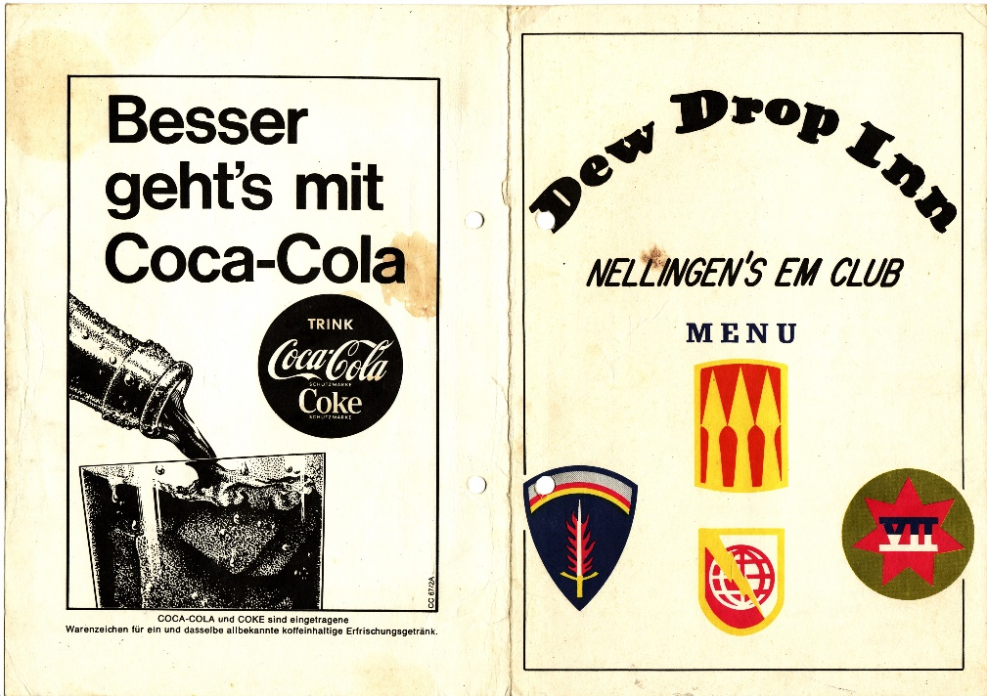
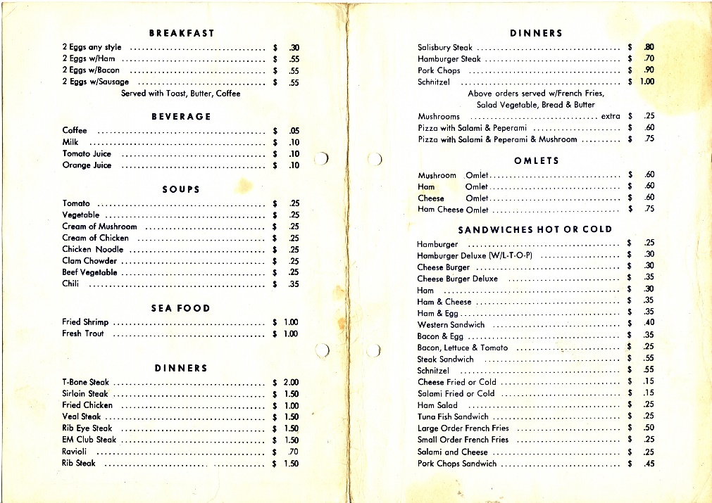
These pictures above were taken in 1991 on some memorabilia trip.
For the first month we stayed at the Gasthof Falken. Either next door or next again, down the road, was a Herties (department store) which we almost lived in.
Opposite our Gasthof was Zum – a snack and I can still taste the bockwurst and karttoffeldalat (boiled sausage and potato salad)
Just around the corner was a curry wurst stand.
Another regular haunt was a jazz kellar not too far from us.
In January and February, we stayed at the Wurtenberger Hof Hotel which was just around the corner. In 1991 we found it closed and I cannot find any info on the net, so it could well be closed for good. I believe that the four rooms at the very top were ours.
This hotel was great as on the weekends there were live bands in the bar. Generally German bands singing “All Or Nossink” by the Small Faces – the Germans could not get their tongues around that title!
When we went to Germany there was 12DM to the pound. Whilst at Esslingen the DM re-valued to 10DM to the pound.
This was great news for us as before it was costing 120DM to send home a tenner but now it was costing us only 100DM.
It worked the other way though for some people. There was, to us, an elderly man lived with us at Gasthof Falken. He had won a Duke of Edinburg Award for the textile industry. His prize was a three months tour of the textile factories in Germany. All his money was in English, so he lost about 16% of his spending money.
Back to the Dew Drop Inn.
After the night was over the respective manager used to pump drinks into us and hopefully get their mitts on Lesley but no chance.
We soon caught on that pay day was big news - the last day of the month. Lesley always had a birthday on the last day of the month. She had three at Nelligen and no one ever sussed it.
The GIs used to give her money for a drink and various other gifts. When we got back to our hotel, we shared out the proceeds.
I had a nice three colour gold ring, which I still have, was part of the share out.
The best one ever was one GIs gave Lesley all his wages. He was in “Air Bourne” – I will explain this. If you did a parachute jump a certain amount of times a year, they got a badge and entitled them to more money.
This GI was fed up with life and was not going to pull the cord – he did and was in the club the next day skint.
I was told once that the only the things that fall out the sky was bird shit and fools – he was one.
There was a brothel in Stuttgart called the “House of Three Colours” – white, black and yellow! Around pay day the yanks used to say “I’m going down the strasse to buy some ass!
The non-smoking GIs came in handy as we used to ask them to get their cheap fag allowance. A carton of 200 cigarette cost 13/6d (68p). Also, they supplied our LPs from their PX (NAAFI).
The draftees were a different animal. They had no interest except going home.
The volunteers were a lot better. I think they had to sign up for an extra year but had a better choice their work.
Herzogenaurach was a high security Kaserne and all volunteers – this will come later.
The favourite questions were;
Does the Queen really live in a palace?
Do you go home every night?
Do you know John Lennon? – I used to say I went to school with him and that always got a free drink!
US Army to them was “Uncle Sam Aint Released Me Yet”
There was always an MA (Master of Arms – bouncer) on duty and generally a huge nigger.
The clubs would not allow “Stag Dancing” – dancing solo and very strict on this.
One guy got up to dance and he was warned and sat down but got up again. This time no more warning the MA got out his “Night Stick” (truncheon) and stabbed the GI straight in the forehead. He went down like a sack of spuds bleeding like hell. We learnt not to mess with these guys.
There always had large jugs of beer on the table and shared.
They loved to play silly games and your forfeit was to have a drink – just like “Pass Out” – another later tale.
We used to lose on purpose and have their beer. The trouble with this was that after a few beers we started making mistakes through the drink and ending up half pissed.
There was a real cool hippie guy with pink tinted glasses called Yippie. He decided that he had enough Germany and determined to get back to his beloved California.
He had a couple trips to the “shrink” (psychologist) and threatened with “suicide” but the doctor did not believe him.
Yippie then decided to drink some Brasso and put some more spice into his “suicide” bid. His mate was to witness him drinking this Brasso – he just said “Prost” and downed it. His mate immediately ran for help and Yippie was carted off to have his stomach pumped.
After a lot of paperwork, he was discharged. The psychologist, when he signed off Yippie, asked him if he was serious and Yippie just said “You will never know”.
Cliff was desperate to upgrade from his Premier kit to a Ludwig kit. He was saving like hell but was a little short.
Sgt Edwards was a real lifer and did not like long hair and bet us all to cut our hair. I think he offered 200$. We thought horror/shock as long hair was essential in this army environment. Cliff saw his new Ludwig kit and let Sgt Edwards give him a GI cut – it took days before we could look at him as he had a huge natural Jimi Hendrix style.
On our last night of the three months we heard that Sgt Edwards, and his henchmen, were going to hijack Bud and I and give us a haircut.
When we finished, we said that we would load up the van and come back in the club for some farewell drinks – we scarpered!
Month three was at Illesheim, near Nurnberg, and was disappointing after the learning curve at Lugwigsburg and the experience of Nelligen and faced a bit of a downer.
See Google Earth location map below.
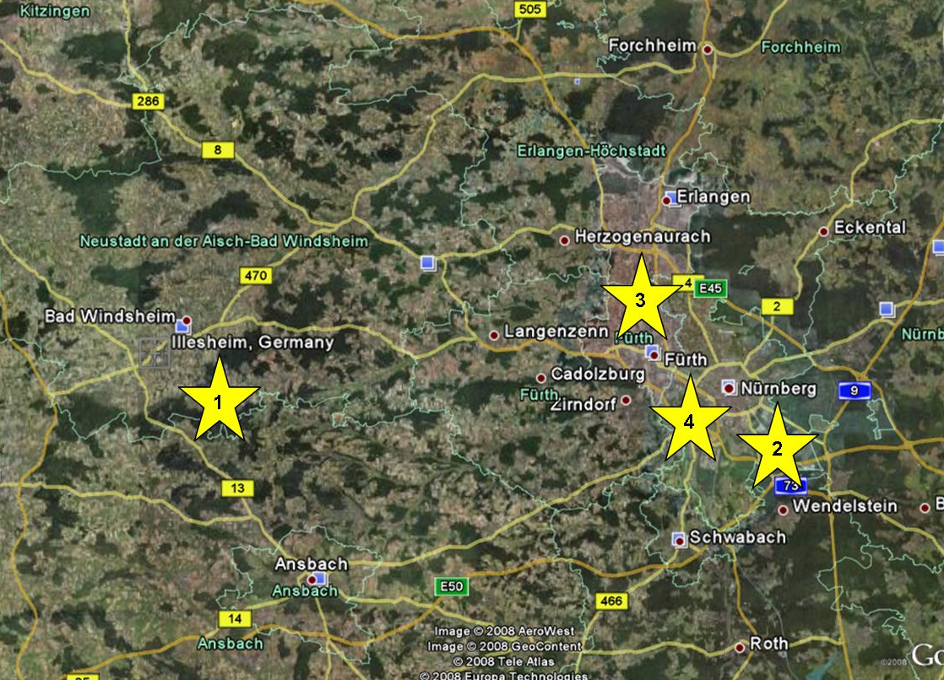
There are four stars on this map – 1 and 4 pinpoint Illesheim and Nurnberg. Herzogenaurach and Furth will crop up later.
The guest house was fine but the Kaserne was very black orientated. I really do not want to harp on about them, but they seemed to hunt in packs like wolves.
We were there for the festive period, but we seemed to have to look over our backs to look after Lesley. They wanted to get their mitts on our white blond singer.
She was very foolish though, and us, as one night she had a disposable paper pink mini dress on.
On stage there was a grand piano and we had had to keep her singing behind the piano as it was too dodgy to front the band from the front.
After saying that yet again we learnt an awful lot – this was month three.
As usual we were always skint, but Cliff was a bit more frugal than the rest of us, so we used to sub off him.
We used to spend money like water. We always had loads of 100 deutshe mark (£10 in those days) but instead of saving it we used to go out to see what we could spend it on. To us it was like Monopoly money.
Our staged payments were 40% on the 15th of the month, 40% at the end of the month and the remaining 20% were on about the following 5th day. We knew the score we still could not keep to budget.
We used to do a bit of cooking in our rooms and at one stay we had to rely on it as even Cliff was at rock bottom after just buying his new kit.
One-day Bud decided to boil up some rice and mix it with some goulash soup. The rice was cooked but no strainer. Bud improvised with his tee shirt – clean one.
Cliff and I had to hold the corners and Bud were to pour in the rice. I dropped the corner and the rice disappeared down the sink. We managed to dismantle the “S” bend to retrieve our rice which as we were so hungry after rinsing it, we carried on with our meals!
We decided to ask downstairs in the bar if we could a tab. It was agreed so we fed and watered the rest of the month.
The main street, where our Gasthof stood, was cobbled. Very early one morning there was a hell of noise as the army was on manoeuvres with loads of tanks passing through our little village. It was very spooky.
Bud, Cliff and Lesley started dabbling with the Ouija board. This was not my scene and I was in the same room. When the glassed moved I turned the light on and disappeared to Lesley’s room.

The next two months were at Nelligen and then off to Babenhausen and Budingen
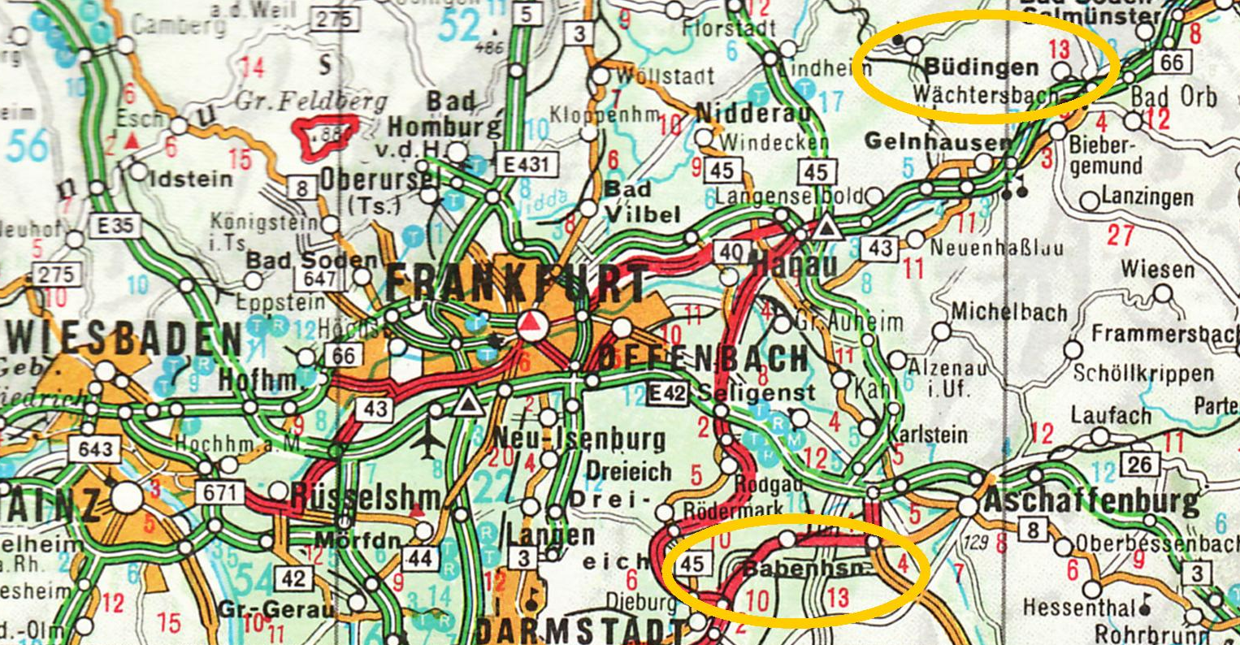
I do not think much must have happened there as I have virtually no memories or pictures in my mind – it has been just a job!
In our repertoire we used Lee Dorsey’s “Ride Your Pony”. In this track there were six-gun shots. Initially Cliff did the effect with rim shots. Later I bought a starting pistol and then I discovered that we could buy tear gas pellets for the gun.
I warned Bud and Cliff and I made sure that Lesley was well up front. When we got to the shots Bud and I kept well back – a lot of people had to leave the room.
A lot of girls carried very small tear gas sprays in their handbags and called anti rape spray.
I will go through the stories of Germany, France and Italy and I will come back and fill in the gaps of the professional career later.
The line-up had now changed with Tommy replaced by Cliff and Terry added on organ.
Off we go to Fulda with our new line-up.
This was for only two weeks and was useful for getting used to each other.
Unknown to us the Magic Children had stayed in this Gasthof and as I lay in bed, I saw written on the ceiling was “Roger Collett Rotted Here”.
The Magic Children did not like the EM clubs and moved to civilian clubs. We were quite happy with the EM clubs as they were very safe, and the money was guaranteed.
We had a girl singer – I cannot remember anything about her and I think was with us for about six to eight weeks.
See map below of the Fulda area.
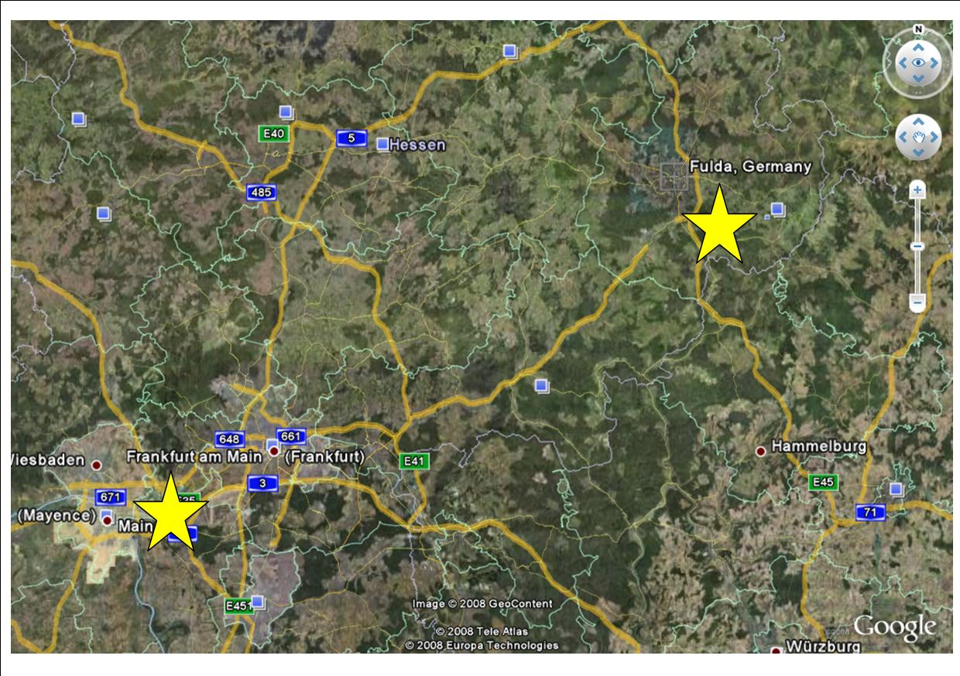
Zweibruchen was a pretty good club and I still have a lot of memory pictures of it, so it must have been OK.
The picture in Chapter 5 page 3 show the four of us sat on the stage.
All the EM clubs they had a weekly “Floor Show” which sometimes gave us a night off or we had just to fill in gaps.
One night the Searchers were on the bill. They used all our kit except the drummer used his own snare drum and their own guitars.

The map below shows Zweibruchen – Karlsruhe and Saarbruchen are “starred” and will crop up later.
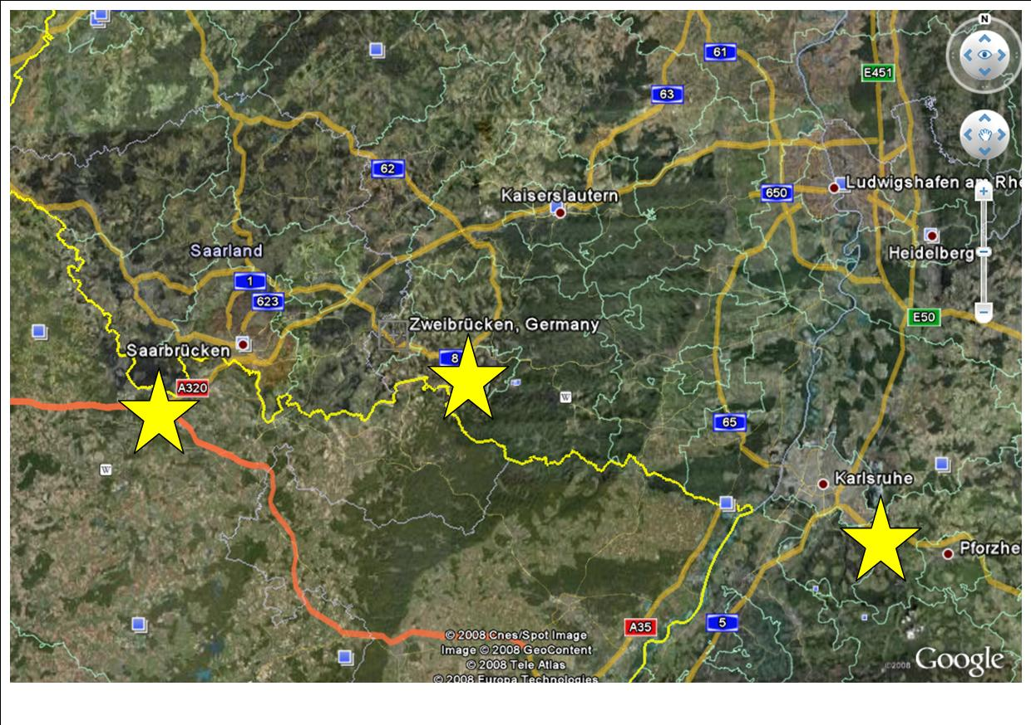
Herzogenaurach was a good club and the GIs were volunteers and dare I say a bit brighter.
This was a high security Kaserne and we had to leave our passports at the gate with the sentries.
We had another girl singer here and the GIs used to give her some stick. She was not the prettiest sight and not a good singer or dancer and older than us. The GIs used to shout out “give granny a song”.
At this club we really did not need a girl singer.
For this month we were very near to the Magic Children as they were based at the Camera Club in Furth. Refer to the map on page 97 stars 3 & 4.
I will digress here:
In Germany when you move area you change number plates. Esslingen plates started with ES and Ludwigsburg was LB. The plates then showed a little disk on the number plate and then two more letters and then numbers. In Furth it was FU – I expect you have twigged it already.
There were lots of plates running around with FU®CK 1234. When the word got well known it was changed!
On our days of we went over to see them and play a few numbers on their equipment, likewise they did the same at Herzo.
At the Camera the punter used to send up pot up to the stage but at Herzo the GIs sent up beer.
The night before pay day was generally the quietist night of the month. Word got around that we were going to jam with the Kids.
We started off the night normally and then say Bud would come off and “Harry” take over – likewise Bud and I would swap from lead to bass and vice versa. At one stage there might be only three of us/them on stage and sometimes all eight. Bud and I even played drums!
Each set of 45 minute was continuous with no breaks.
This night was a massive success, the stage was crammed full of bottles of beer and many encores were called. We would have played another hour, but the dreaded MAs stepped in to stop the show. A mini riot evolved, and I was frog marched off the camp and the band were sacked!
This was absolute stupidity as the next day was pay day and no band!
One of the GIs who typed up the report sent us a photocopy of it and apparently that the bar take was the record even – the day before pay day at that!

We stayed at a lovely Gasthof quite near the camp.
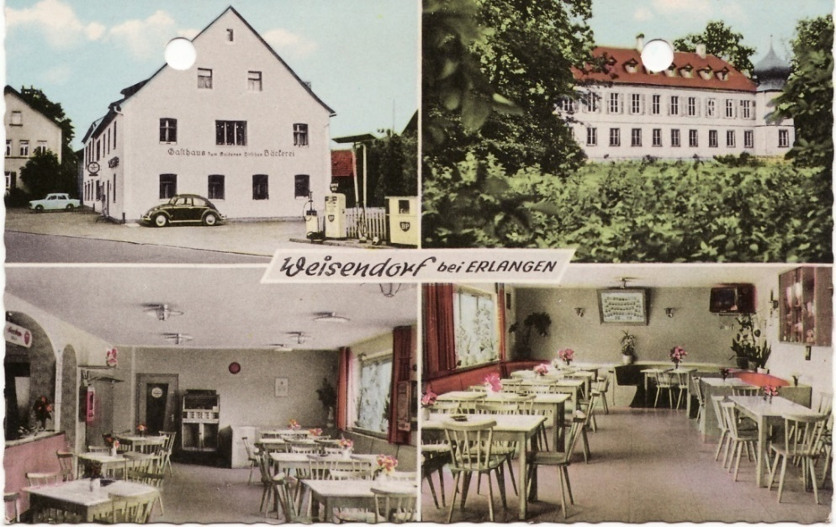
It was always difficult to find accommodation because of what we looked like - English musicians with long hair. The thought of us staying there a month really put them off.
We struggled to find a place to stay in the Herzo area and begrudgingly we could stay here for only a couple nights – this was a typical routine for other places.
We were always accepted and allowed to stay for the duration. We then negotiate a cheaper rate for a long stay and that we would eat and drink here.
This couple, and all the locals, really loved us and we spent a lot of time and money with them – especially feeding that jukebox in the picture. Even the locals used to play tracks for us!
The day we left we loaded up – all the equipment inside and all our cases on the roof. We were called back in for a farewell drink. Whilst having slurps there was an explosion outside, we looked at our van and front seat was in bits.
The couple thought that someone had sabotaged our van and started to cry.
The spare wheel, behind the seat, had blown up causing the damage – remember the story in the Spartan days?
We patched up the seat and off we went, and the couple were still sobbing as they knew they were going to miss us.
Bad Kreuznach – always known as BK.
A great town and there were a lot going on.
Sadly, the only picture to show is the McDonalds, below, taken in 1991.
Sue and I had a snack there to quiz about the former site. Yes, it was the home of the Central Hotel where we stayed in July 1969.
Bud and my room overlooked the bus and train stations and spent hours watching the word go by.
We quickly learned that there were a couple prostitutes stayed there and we befriended them – not physically. All we seemed to be doing was letting customers in and out the front door.
They wandered around just like us as mates and I remember one of them was in our room, in her dressing gown, and decided to brush the hairy bit!
This might seem unsavoury, but prostitution was legal, and all were “clean” and tested regularly – a public service!
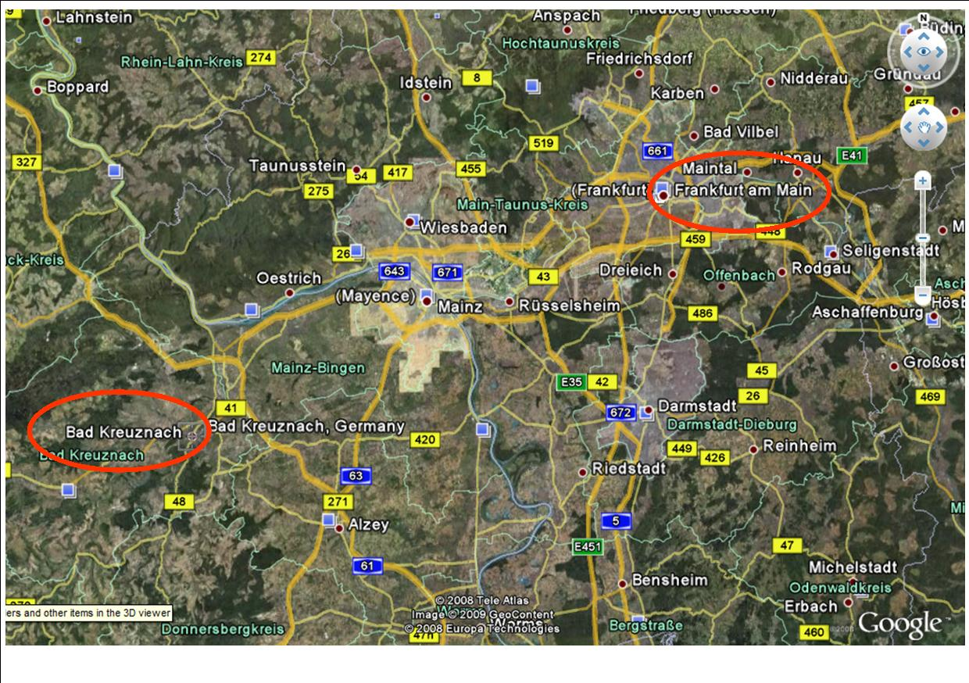
We had yet another Exeter band were on their first tour and came to see us. I have forgotten the name of the band at this moment but there was “a very pretty little boy, in the band, called Primrose” and still a v****n.
We all clubbed together and paid for the services of our hotel friends to look after Primrose.
A tape recorder was set going under the bed and the pro was set loose. Unfortunately, Primrose locked himself in the cupboard and all we got on the recording was “I don’t want it, I don’t want it”.
The money was not wasted as a medic Sgt was with us and used the facilities – tape still running!
We had just got into stereo recordings. Bud bought the first machine and the most remembered albums were Pink Floyd – Piper At The Gates Of Dawn and the Moody Blues.
The Magic Children, at one staged, played in BK and we were not far from them at this stage as they were playing in Frankfurt.
One night off we popped across to see them at their club. I asked for direction in German for Kaiserstrasse – bearing in mind we have a left-hand drive van with international plates. The reply was in perfect BBC voice – “I have not the faintest idea”.
There were a lot of drugs at this club and six of them dabbled with pot (hash), speed (methylin) and acid (LSD). John and I were never interested so we would go clubbing.
The six – Bud, Tommy, Terry, Rog, Dave and “Harry” used to hide in dark attics passing around the pipe.
I came back from a club one night and I was passed the pipe and I was slightly ill, and John was goofing with it and Dave in his Devon/American accent said, “why is John such an un-cool name”.
With LSD I laid the law down. This was only to be taken straight after a gig so that there was a full forty-eight hours before we played again.
They wandered around Frankfurt zoo one day “grooving on the lights!” and eating ice cream which “exploded in their mouth” – they were then told that sugar/ice cream would bring them down from their “trip” quicker.
At BK we learnt that an “over the counter” drug was available containing speed. It was the UK version of Pro-Plus but a lot stronger.
Apparently, it was designed to keep you awake if feeling tired – driving or in our case just knackered.
The recommended dosage was one or two. Bud, Tommy and Terry would take three or four and stay up all night and just talk until their mouths literally dried up. They went a week without going to bed.
I got involved with this lot as, in theory this was legal, but to get a “buzz” I used to take about six, but I would get knackered and go the bed.
I talked to the medic, involved in the pro story, looked at the ingredients and told us to stay well clear. The other three had “cold turkey” for a few days but no damage.
The pot, in my opinion, is possibly less harmful than alcohol but my principles were that it was illegal!
We got friendly with two sisters from the fair. They were good mates and nothing else than that. They had a Merc and we were chuffed to be ferried around in this.
Their Dad was dead, but they wanted to try and find him in the grave yard at BK in the middle of the night. After a couple of beers, we all go ghost hunting - but I kept well back.
The sisters go in searching way up in front and then a huge scream and they “see their Dad sat on the grave” – I was gone! Apparently, I cleared about seven steps and a little wall with one leap and within a couple second, I was locked in the back of the Merc.
We saw the moon landing on the TV at the EM club – on black and white. The yanks enjoyed that!
On one of our nights off we took all our gear into the “Belle Napolis” night club in BK – we ever worked on our night off!
After our great time at BK we were off to Smiley Barracks at Karlsruhe.
I have no mental picture of the EM club but “pictures” of our hotel, the local disco and just down the road, new to us, was a hypermarket.
I used the local disco a lot on my own or with John if their band was over with us. As usual the others would do their thing and I would go clubbing – on the piss.
The hypermarket was huge. Literally you could buy anything from a pin to a car. A lot of time was spent wandering around there.
We befriended a GIs and they were into hypnotism. Yet again, like the Ouija board, ghost hunting and drugs, I kept out the way – I sound like a whimp! – but I have principles.
I was up in my room one afternoon and Bud phoned me from Tommy and Terry’s room and asked if I would drop these GIs to the station – after this he said “I love you” – these GIs had hypnotised Bud to say this.
We were told later that after the first number Terry would stand up and say “It will be a jolly good night” – a phrase he would never use.
We got to the club and told a few GIs what was planned. As to plan it happened exactly. We knew, the GIs knew, we all burst out laughing and poor Terry was looking completely bewildered.
Bud and Terry were easy, but they could not hypnotise Tommy and I was out of it. I do believe of it though over the years I have seen many acts and it is real.
Our tour was over, but we learnt that the Go in at Saarbruchen was “out of favour” and we were offered to try and build it up and take a share of the profits. We played there on the 3rd & 4th of September 1969 and little response. We then had a big publicity stump by playing in the main street (Bahnhofstrasse) caused havoc with the traffic and about 1000 people turned up. We played at the club the same night with no improvement, so we went home the next day.
There are a couple of snippets from Germany that I have forgotten. In the various EM and Sgts Mess clubs we bumped into a few “floor show” acts.
Two other acts always on tour were Mandy and the Girlfriends – an all-girl band which left the yanks with their tongues hanging out.
Also, Cherry Wainer and, I think her husband, Don Storer on drums. She arrived on stage with two white poodles and played possibly an M3 Hammond all finished in white pearl. She was good with the foot pedals. I think she used to appear on 6 5 Special from the late fifties.

In the 1969/70 period Paris was undoubtedly the best place to ever live.
Our hotel was in Rue Copernic (1), our regular café on Rue Lauriston (2) - it was either No 66 or the Paris flat of Jean Besnard and The Arc De Triomphe (3) leading to Champs-Elysees.
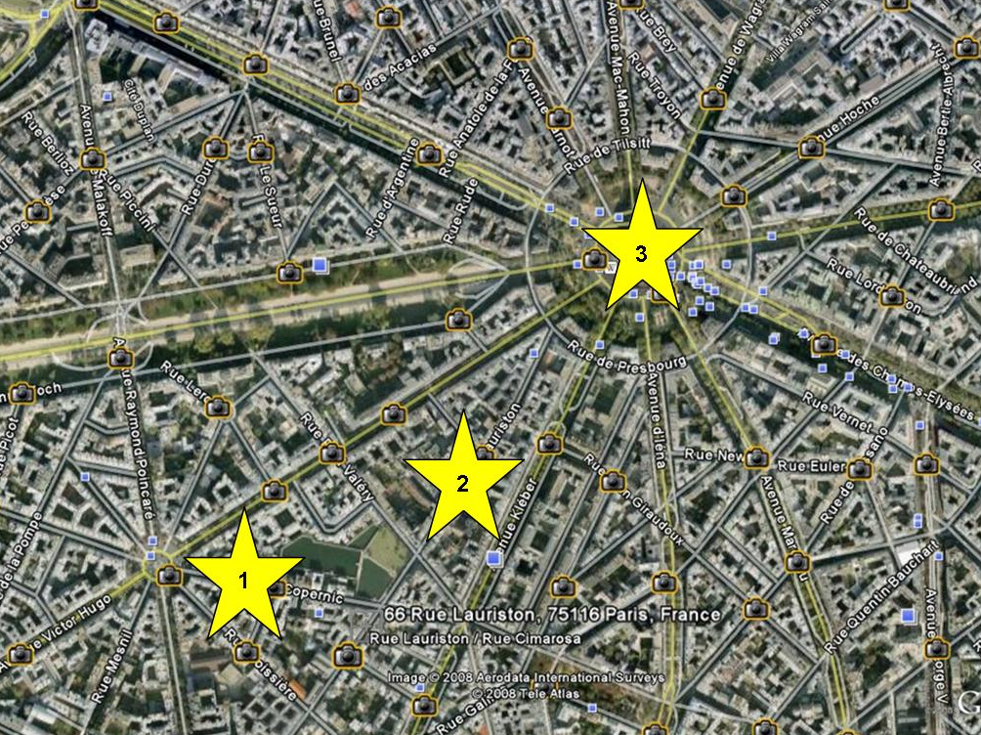
Jean Besnard was our manager in Paris.
He was an actor & had an Entertainment Agency - a very typical, fiery Frenchman but a great character.
Jean financed the original Paris recordings and bought us some new stage clothes.
At one session, in the studio, Jean was getting annoyed with band's performance so to spice it up he put a female stripper in the studio - that did not quite do the job but four bottles of champagne later it worked.
Jean was only interested in the band's own compositions but when he was out of the studio two more tracks were cut on a 45 acetate - Exodus & Better By You, Better Than Me (by Spooky Tooth). Four copies were made but currently not available.
Jean used to watch me from his flat and he used to shout out of his window at me with all the swear words he knew but, in those days, he did not understand what the words meant – I did, and I cringed!
Our VW had windows and was allowed on the Champs-Elysees. Our faithful VW died in Paris and we hired a Renault van to ferry us to the Golf Drouot. I did not know that commercial vehicles were not allowed on the Champs-Elysees - feeder roads were obviously OK.
I trundled off to the club via the Champs-Elysees, unfortunately with Jean beside me – he went bonkers! The police did not spot me, and I got away with it.
The Golf Drouot was the equivalent to the Marquee in London and we were accepted well.
We were then off to Rome and Jean, after his investment with the recordings and clothes, was afraid we would disappear back to the UK after the Rome contract. He held retention on us and released just enough money for us to get to Rome and told us to sub some money when we got there – that is exactly what we did.
The Piper Club was well known and still exists.
The photos below show the location from Google Earth and the club internal pictures are pinched from the internet and are allegedly in 1970.
My main memory of Rome was always standing in dog shit. The place was filthy.
Rome was not my favourite place in those days, compared to Paris, but I hope to go back and have another look. Our van was out of action for the two weeks, so we did not see as many sights as we should have so perhaps, I would have had a different opinion if I explores more.
Whilst we were in Paris, we picked up a brand-new track called Venus by Shocking Blue. This was a big hit there but not known to the rest of the world. We had it well-rehearsed and have it in Rome - a good investment as we had to play this about three times a night!
The virtually only Italian I knew, other than please or thank you, was F Off. I learnt this from Chris (Forte) who was of Italian descent – a distant relation of Charles Forte – as in hotels.
All our equipment was set up and there were workmen working on the back drop and making one hell of a mess of our kit. I had to use the Italian version and I did not realize until then that these little Italians were a little bit over excited – I got away with it, but it took a while to cool those little wops!
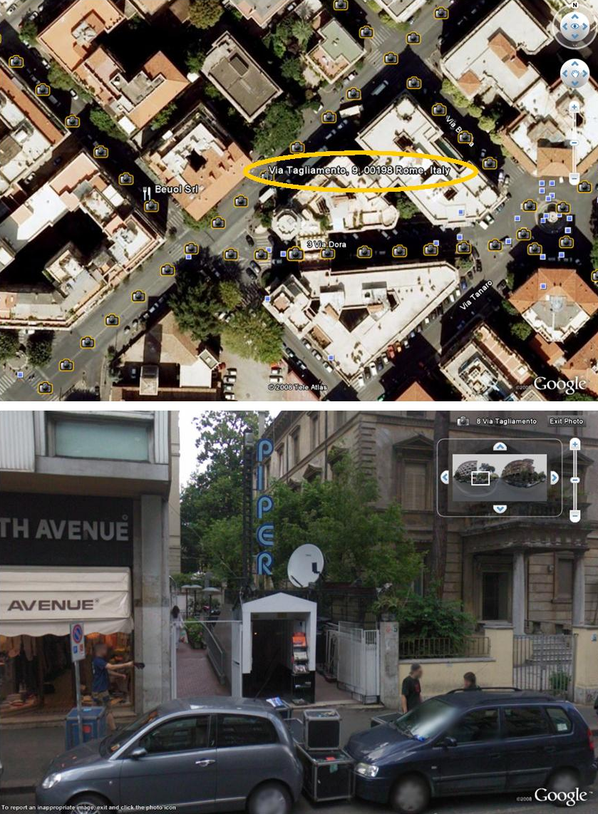
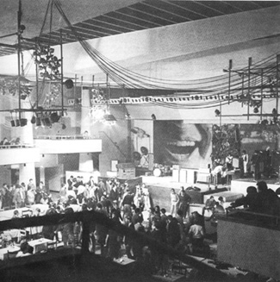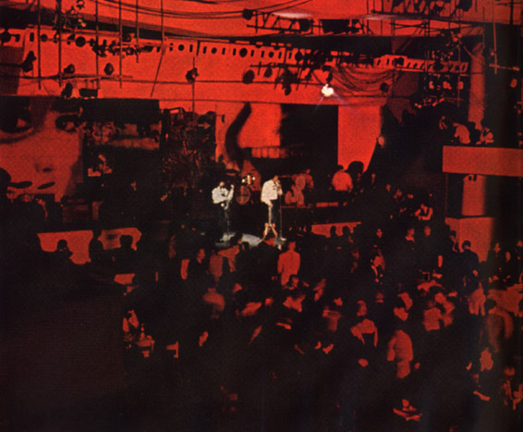
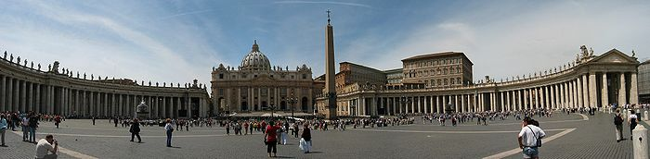
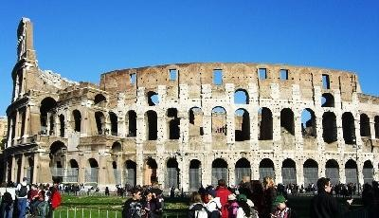
We visited the Vatican City of course and the Colosseum - I was a bit disappointed as we must have been too late as it had started to fall down! – pictures above pinched from the internet.
These photos below are from my memorabilia pile – San Pietro and Fontana Di Trevi.
On the bill one night there was the Rainy Day Woman from Sweden.
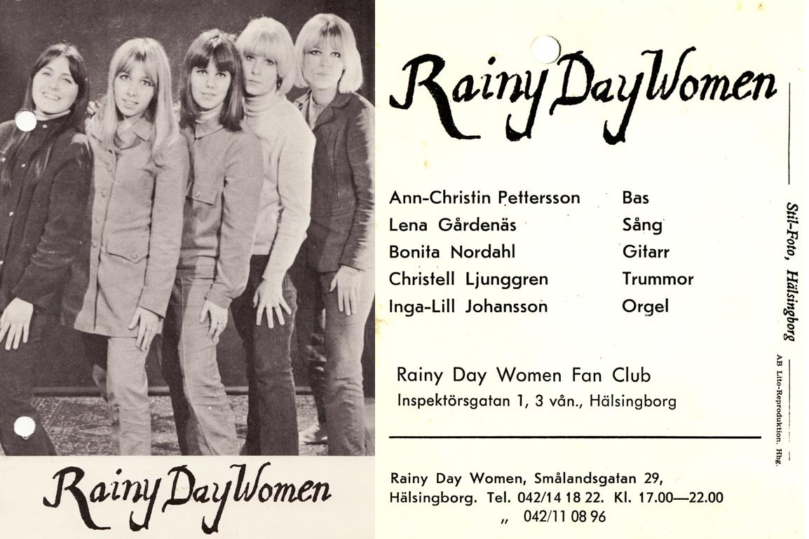
Yes, it must have been a good club as I still have my mind picture approaching forty years ago.
When we got back from Rome, we popped into the Golf Drouot and we saw a poster advertising that Wishbone Ash was playing there in a few days’ time.
We told the owner/manager that there was a good band coming.
Wishbone Ash evolved from the Empty Vessels (also known as M.T. Vessels). This band comprised of Martin Turner (bass), his younger brother Glenn (lead) and Steve Upton (drums). Martin Turner was the M.T in Vessels!
The two brothers moved from Torquay to Exeter with fellow Exonian Steve. The three later moved to London and changed the name of the band to Tanglewood with the aim to make their fame and fortune.
Later Glen returned to Torquay.
Next Wishbone Ash is born, and we see one of their first performances at Tiffany’s in Exeter. Two lead guitarists were added Andy Powell and Ted Turner – no relation. It was a good gig.
Back in Paris we arrive as Wishbone Ash was starting their first song – “Blind Eye”. Martin and Steve were gob smacked to see us there. They did not know we were on tour, yet along living in Paris.
Later when the owner/manager of the Golf Drouot heard the band he said that this band will be big – he was right.
I did find some info on Glenn some months ago, on the internet, about his work since Empty Vessels days but I cannot find this at moment.
There was yet a younger brother called Kim. He used to jam with us at the youth clubs in Torquay and he was a very good drummer then – probably aged about fourteen.
In the early 70s he joined Cat Iron – a band managed by Miles Copeland. He then played with Andy Fraser (ex-Free) and in 1978 he joined an up and coming band - the Police as road manager and sound engineer.
Kim sadly passed away on May 12th, 2003, following a brave fight against cancer.
Mile Copeland was also involved with the Empty Vessels and Wishbone Ash.
The 1970 diary is missing so the Paris/France gigs are completely from memory.

We went to two ski resorts – the first one was Les Deux-Alpes.
I think we were there a week.
The club was very expensive and the prices in 1970 were £1/7/6 (£1.39p) for a Coke and £2/7/6 (£2.39p) for a beer - it would be about 5/= (25p) in the UK.
There were a lot of “rich kids” at this club and we saw the same people every night pissed up – it must have cost them a fortune.
I was lucky as a lovely young girl chatted me up and kept me in beer. All she wanted was to talk to me and help her with her English. I wanted a bit more than talking and I caught the crabs off her!
I did meet her again when we got back to Paris. I think she was rich as the family lived in a huge house.
On the left photo in the centre there is a chair lift right to the top – not shown on this post card. All four of us decided to go to the top.
When you get to the top the chairs do not stop. All you have to do is just ski off – but we were in shoes! Needless to say, a couple of us ended up on our asses.
If you look at the left photo again you can see a skating rink. From the top it just looked like a postage stamp.
How do we get down? Of course, back into the chair lift. We are the only four going down – this reminds me of the “Bucket of Bricks” story – “half way up the barrel became lighter…….”
Coming up all the chairs are full and only two chairs going down. People were pointing, laughing, cheering and clapping to us.
Again, at the bottom a couple of us landed up in heaps.
The other ski resort was Le Mont-Dore.
This was the opposite of Les Deux-Alpes as this was a very cheap resort.
The club was unique to us. During the day it was used as a restaurant/café but at night it was a night club.
The front entrance was shuttered up and then the windows inside were covered by artwork panels.
The ceiling was lowered on pulleys to create a cosier atmosphere and disco and UV lighting added to finish he effect.
The entrance now was by the rear door, so it seemed like you were in a completely different building. Some people did not even realize that their lunchtime meal was in the same room!
At the end of the night the shutters and panels removed, and the ceiling pulled up again already for breakfast – very clever.
We were there for a week I think - I am lost without my 1970 diary!
At both of the ski resorts we played a lot of Monopoly. We had four sets – English, American, French and German.
Other times we spent hours wandering around the shops and the towns but all we could see was snow and it was cold.
When we finished on the last night, we decided not to go to bed but drive to the next gig - and our target was to get to Clermont-Ferrand (from 1 to 2) for some reason.

See next map.
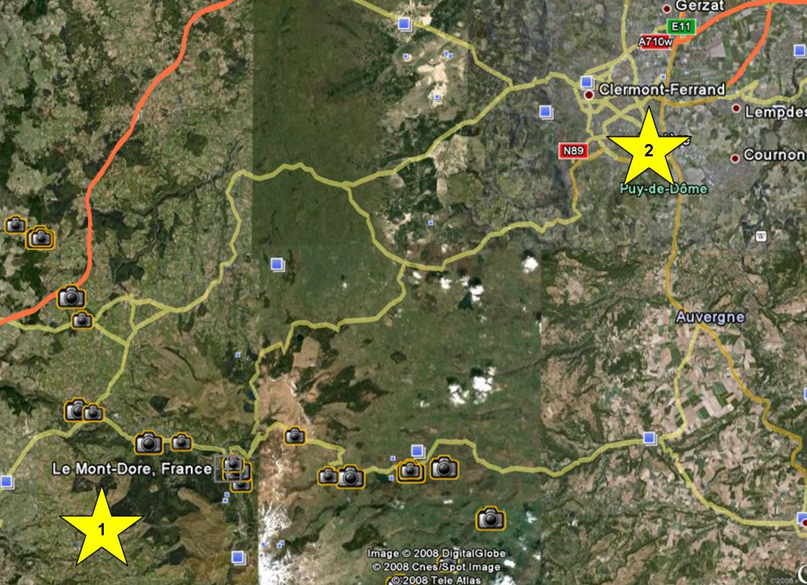
Everybody told us that the road was un-passable – it had recently snowed and there was a steep hill to get out of Le Mont-Dore.
We decided to press on. I was driving and one of the others was in the passenger seat used as an extra pair of eyes looking for snowdrifts. The other two were standing and the rear bumper jumping up and down to create a bit more grip. We made it – but then got a puncture!
No problem we jacked it up, but the spare was frozen solid. This was a Ford Thames and the spare was stored underneath.
The only answer was to wait for help and kept the engine running to keep us warm.
At one stage Bud woke up with a start and shouted at me for falling asleep at the wheel – I told him in some not too polite way that the van was still on the jack and would not get very far!
At about six in the morning a couple guys in a pickup. Two of the band climbed in the back of the pickup with the punctured tyre.
They returned after an hour or so. They were freezing back of the pickup but managed to get some breakfast at the local café/garage.
There were amazed to see lorry drivers at 6:00am having breakfast drinking red wine!
We were soon on the road and got to the main road at Clermont-Ferrand and then off to the gig wherever it was.
In Paris we played in an apartment belonged to an MP or equally famous. We played in the hall way. There could well have been many famous people there, but it was just a gig to us.
Another good gig was in a Chateau in the Bois De Boulogne. The room was decorated with fresh fruit as Christmas trimmings. There were two bands on the bill and we did one hour on and one hour off. This went on until 5:00am and I think it started at 9:00pm the night before. All the yuppies were there!
The chateau was in large grounds and about four entrances – three were closed. When we had packed up, we headed for the exit. I aimed for the wrong gate and demolished it and put a few dents to the front of the van. We had had a few drinks, but we were not too far from Victor Hugo.
Bud and Jen honeymooned at 147 Exeter Road and whilst there we had a phone call from France that the “Graded Grains” were required for a few days over there. The line up on this mini tour was just Bud, me and John C. We took Jen, as still on honeymoon, and I took my current girlfriend, Janet (Perks) – ex Spartans and ex long girlfriend of Roger (Collett). Bud and I took the girls and John on a whistle stop tour of Paris including the Eiffel Tower and the haunts of the previous trip.
We did the gig, very few turned up and we were not paid so we come home! – but at least we could boast that Bud and Jen “honeymooned in Paris”.
I’ll go back to fill in the gaps whilst professional at home.
We played in the Cedar Club twice in Birmingham. It was a very posh casino.
We had to play ridiculously quiet and Tommy used brushes! – not suitable for Hendrix, Cream and Who!
The beer was sold in half pints and it cost 5/= - this was 10/= a pint! – 50p which was crazy money.
The first time we played there about six to eight guys came in – long hair and in denim. All the rest of the punters were suited or in diner jackets – there were all the Move and the others from a semi named Brum band whose name has been lost for the minute.
We all had a yarn and Carl Wayne, the lead singer at that time, was very generous handing out his Park Drive Plain. Only a few weeks later we supported them at Torquay Town Hall.
We were at a gig at the George Hotel in Walsaw. There was another band on with us and was a Beach Boys type band called the Californians. I never saw it before or since was that drummer stood up!
Up at the Regal in Beverly with all the gear set up we were advised to experience a pub called Nellie’s (White Horse Inn). We were warned that Nellie’s Old (Younger’s Number 3) was a pretty potent brew.
The pub was run by two very elderly sisters.
Tommy was a good drinker as he was brought up in the Kings Arms in Cowick Street and thought he could drink. Us three after about two or three pints were knew that we had a drink. Tommy decided to have a couple more. He played brilliant but admitted later that he could not remember playing the first set!
I think very similar to the Nobody Inn at Doddiscombesleigh as it was.
One night we played with the Crazy World of Arthur Brown at Tavistock Town Hall. I might be wrong, but I believe that Carl Palmer was on drums and Keith Emerson on organ – Emerson, Lake & Palmer.
It was, I think, was a Hammond M3 and it was playing up. The roadies took the organ completely apart and all the bits were spread all over the stage. We could us playing on our own, but it was repaired, and the show went on.
After the gig we met up with the band at the transport café just outside Okehampton and I believe it was sited somewhere near where Mole Avon is now.
In those days most of the bands travelled in their Transits or the better off ones followed by car, so we often saw the well-known bands in the transport cafes and motorway service stations. We saw the Kinks a couple times and the Swinging Blue Jeans.
At Torquay Town Hall Lionel Digby used to put on the big acts in the summer. The bands use to earn about £300/£400 a night. It was about 12/6d admission and Lionel needed about 700 customers to break even. If he got 800, he did OK.
Hendrix was now big new and started to demand £1000. This now meant that Lionel had to charge over £1 a head and pack the hall to the 1000 limit. That really was the start of big money in the music industry – but it was the end of seeing a top act for less than a quid!
During this professional period, we went to London a few times and we went to the “Marquee” a couple time.
“Canned Heat” was on the bill one day at the time of “On The Road Again”. Before the band started there was an announcement that no one was to stand in front of the speakers without ear defenders. The band was pretty loud but, as in those days, all amp had 12” speakers and just pumped out the “middle range”.
Most of the sound was absorbed by the crowd – these would never pass the regulations as today.
The second time we went there “Family” was the support act. I am sorry, but I never got into them and after playing with them in Torquay, seeing them in Paris and then in the “Marquee” I still did not like them.
Top of the bill was “Cream”. This was incredibly hot and most of the crowd took off their shirts. The heat caused someone to spewed down Bud’s back!
“Cream” started with “Tales Of Brave Ulysses”. This was the first time that I had heard a wah-wah pedal and that completely knocked us out. Every guitarist in the land now added a wah-wah pedal to the fuzz box!
“Cream” were great but the biggest memory was the heat and the amount of bodies crammed in there.
In our travels we also saw a few other bands around the late seventies/early eighties.
We see “AC/DC” at the N.E.C. and it was easy to pop down to the “Cornwall Coliseum” and we saw “Thin Lizzy” and “Status Quo” two or three times. These were all good concerts.
Our claim to fame was “Status Quo” mentioned the “Graded Grains” at the “Coliseum” by wishing us luck with our music.
The connection was that Gary’s brother in law lived near Alan Lancaster (original bass player of Quo) in Australia. He told about this local band in the West Country that played a lot of Quo material. Just after Alan left Quo as he was fed up with coming back from Australia for tours.
Steve Orgee was a pretty talented guy. He was left handed and he picked up my banjo once and got a tune out of it upside down! – as left handed. He composed his songs on the piano with the black notes and was quite good on the piano.
Over the years we worked with many comics and I told a lot of jokes on stage. My tester was always – “A bloke went into a jeweller shop and flopped his tool on the counter – sorry sir this is a clock shop not a cock shop – I know put two hands on it”. If we had a good laugh from it, we knew we were OK. If not, we had to clean the act up a bit!
I was looking at a Jethro DVD a few days and he mentioned Johnny Walker who on the circuit the same time as us. His line was “My name is Johnny Walker, my wife is called Ruth – once a month I call her Redruth” – I used to cringe at that one.
We worked with Jethro once and saw him doing a stag show at the Riverside in Exeter.
We were at a “Showcase” with Jethro – he was the compere. A Showcase was where all the booking agents came to see the local acts. We went to two of these.
On both occasions we planned to take in half the gear and play all the twee songs like “Beautiful Sunday”. Both times though we were a long way down the bill, the beer took over and all the gear came in and we blasted out Quo. When we finished Jethro just turned to the bookers and said, “Did e yer um?”.
We worked many times with Tony Beard and I even booked him at Potters many years after the band days. Also, we worked his cousin Dave Beard in a pantomime we were in. Mike Swan was also in the panto and worked with him many times on the road.
My favourite joke was from Ken Harris. “I saw my wife bending over the chest freezer and wearing a mini skirt with susies. (suspenders). I just could not resist it so gave her a portion. Feeling a bit guilty I went to see Father Confessor and told him what I had done, and would I be banished from the church. Father Confessor said that one moment of lust would get him banished. Thanks, but I’m banned from Tescos!”
In 1984 we played at a midnight show at the Radnor Cinema in Sidmouth. Top of the bill was Frank Carson. There were a couple other acts on the bill. We started the show with a music set, then a couple acts, then us with our comedy routine and Frank Carson was to close the show.
The show went on a bit longer than expected and Frank wanted to swap over the two sets so that we would go on last. No way would this work for us as the cinema would empty after the star turn.
One of the reasons why we were booked was to supply our PA system for all the acts.
The deal was swapping the running order or no PA. We won obviously but Frank was not too happy. He put on a good show though. A few weeks later same bill with Frank at the Police Club in Torquay – we were still friends.
In January 1977 we were roped into appearing in a pantomime, Jack and the Beanstalk, at the Queens Hall, Barnstaple by Lionel Digby – pages 69 & 70. It ran from 3rd to 8th with eleven performances.
Lionel’s sister, Roberta, was the “producer” – she was a waste of space. The run up to the show was a pantomime on its own with lack of props and costumes and we never ever did a full-dress rehearsal of the second set!
On the day it was a great success with a good report in “The Stage”. I think it was greatly created by the skill and enthusiasm of Dave Beard who was so professional.
There was an elderly guy in the front row that watched all the performances and really grooved on the “cock ups” and ad libs but he thought the shows were brilliant.
Mike (Swan) liked his pint and on Market Day the bar was open all day. He led Chris (Chambers) astray and Chris fell down and could not perform so the show carried on without “Simple Simon” and we got away with it.
We played as the Graded Grains and acted as well.
Bud and Gary were Twiddle and Twaddle and I was the Giant’s Henchman.
Lionel was the giant, but I was taller than him. To enlarge the Giant, Lionel wore a big head planted on his head dressed up in a hood. His head fell off at one performance and it rolled across the stage disclosed a big head of Oliver Hardy!
In one part there was an eviction routine and all the home contents were thrown out. In the mayhem a potty was left on the stage and it was Ysanne (Usherwood)’s turn to sing a pretty little song - with this chamber in front of her.
Bud, Gary and I were offstage for the last ten minutes or so in the first set. We used to find our way to the bar on the balcony and watch, with a pint, these last few minutes. We were up there one night, and the beanstalk was meant to grow but when hauled up the backdrop and bits of scenery went up with it. We died of laughter but none of the cast could see it as their backs were to it!
There was a constant flow of alcohols as the stage hands had access to the pub next door so there was always a pint available in the wings.
After the pantomime was over, we felt empty as we lived at such a fast pace and now it had stopped. I knew then what the acts must feel like after a summer seasons or stage shows - there is a huge void at the end!
Back in New Year’s Day 1982 we were asked to perform at a charity dance at St Blazey Football Club in aid of the Penlee Lifeboat disaster fund. We offered our services free and we charged the two roadies £5 each and £10 for petrol – a total of £20.
When we set up the main PA failed. I spent a lot of time and effort juggling the various commutations of the PA and I got it going – not 100% but I got some noise out of it. We had very few punters arrive and at the end of the night they refused to pay us.
We were wicked – OK we could not perform 100% but have a charity function on New Year’s Day? Looking around the dressing room I spied an HH amp going begging, so I put that in the van to cover our expenses. Unfortunately, the police were knocking on my door a couple days later in Exmouth and Gary, on his rep days, returned it a couple days later! The rule then was no more charity work.
I have now got to mention village hall caretakers – they are a breed of their own. Very few could leave us alone to get on with packing the gear, loading the van and going home.
They always wanted everybody out double quick.
All it changed when we started employing roadies in about 1975. Up until then we had a few minutes getting off our sweaty stage clothes and then into normal clothes and then go like hell to get on the road.
Initially we had Clive, nicknamed by Steve as the “Fat Toad” which was shortened to “Toad”. It was too much for one, so we soon took on another. We ending up with about ten on the books and paid them about a fiver and took in turns to drive and the other could have a drink in moderation.
We used to tell the bookers that our job was finished when we finished the last chord. We told everybody it would take about one hour to strip the gear and load the van. If there was a long haul, we either had an extra roadie on or us three bail in at the end.
There were generally no problems with the clubs as the floors had to be cleaned and glasses to be washed and generally, we all finished at the same time.
Now the caretaker had been tucked away at home in the warmed watching their TV and now the dance has finished at say 1:00am and he or she would have trudge across from their warm pits and lock the hall up.
We three would be sat around joking and laughing and of course a tin or two of Heineken.
The caretakers did not like this as we should be working!
There were probably enough stories to write a book on the caretakers, but I have picked out four.
New Year’s Eve 1973 Contraband was booked for the Parish Hall at Bere Alston.
As well as the caretaker this lady was involved with the committee or organisation of tonight’s dance. She thought she was running the show.
Whist doing the sound checks she was drivelling on about the volume and the type of song we were rehearsing. I had enough and made it known to her that I was off to the phone box and see if Lionel had another gigs for tonight as this was still in the afternoon. Off I go, to wind her up, to the phone box. She then twigged from the others that I was seriously trying to find another gig.
By now I was in the phone box pretended to be talking to Lionel. She fell for it – she banged on the door and begged me to hang up.
She kept her distance at the start of the night but as the night went on, she was involved in every game we set up and could not thank us enough at the end of the night – we never went back though next year!
I will digress: We had years of experience and I hated someone telling us what to do – request something was of course fine but to tell us that it was too loud or the wrong material. In the later years the roadies had the control of the volume by the mixing desk at the back of the room.
There were many gigs we went to and we thought why this agent has sent us to this venue. The times we were given the Free Masons, Rotary Club and Round Table all in Dinner Jackets and long gowns but … we were experts of kidology!
We never used a play list. I was the front man and the others did not have a clue what was coming next until I introduced it.
All we had was about three waltzes, three quick steps and possible busk a couple instruments as quick steps. Then we had to rely on the corny stuff like “Beautiful Sunday” and then onto pop, Beatles and by the end of the night we were well into ribald humour and plenty of Status Quo.
This worked on a 99% success rate – back to the plot.
The next story was not a caretaker but a problem at the Grenofen Manor Country Club. It was quite a good night, but the bouncers, manager or owner wanted us out super quick.
There were various rooms in this sprawling old manor, so I hid in a dark corner to have fag and a pint. One of the guys found me and was very heavy shouting at me to get on and pack the gear.
In the end the dogs were brought out and if we did not work like hell to get loaded, I am sure the dogs would have been set on us.
I really do not know what all the fuss was about to get us out so quick. It might have been that the staff wanted to settle down for a piss up or perhaps something more sinister?
Right back to conventionally village hall but I cannot remember where. It was a brilliant night and we were running overtime with encores. The caretaker gave me the sign to knock it on the head, but I wanted to chuck in Slade’s “Merry Christmas” to end the night. The stupid bugger turned off the main switch – I went bananas as the amps had to be turned on and off in a certain order or else the surge would blow the horns. Before I got to stack of amps, to turn them off, he turned the mains on and blew one of the horns.
To say the least, we all went on super slow to teach him a lesson.
Another classic was I thought it might have been at Millbrook, just in Cornwall, but I cannot find it in the diaries. Anyway, it was lovely little hall, tidy, clean with a very highly polished floor.
As usual we had a good night and settled down for the statutory fag and a couple tins of lager. Off he goes moaning at us. As it happened it was a very short hump and the roadies would have cleared this lot in forty-five minutes.
He carried on, we ignored him, he wandered off and came back with a dog – a little terrier sized thing. This animal was supposed to frighten me off, so I barked at it and it shook with fear.
The caretaker said to the dog “kill”. I barked back louder, and the dog cowered behind the caretaker. With that he picked up the dog and threw it at me. The dog slid down my body looking petrified and when it pitched on the floor, he had no grip as the floor was so highly polished! – just like Dino from the Flintstones. If only it was videoed!
We got up to many pranks and one occasion we were at a barn dance. The huge barn was split into two. We played in one barn which was cleared, and we changed in the other barn which was full of farming bits. Bud spotted a circular cattle feeder and decided to be like a “hamster’s wheel”.
As usual with the lager in Bud was fearless hurtling down and back up this barn. Sometimes the wheel went out of control, sometimes Bud out of control and both times both. The only savour this sight was to be there! Any slip the fingers could have badly damaged or worse.
I kept away from this one as hurting fingers put the band off the road and playing a six-string guitar hurt a lot more than a bass guitar.
Gary could keep up with my lager intake, likewise Bud, but when loaded into the van he just slipped into a coma and we could do anything to him and we played many tricks on him.
It was known to leave him in the van as the roadies could not wake him up and a few hours later he got cold, wake up and had to walk home!
Tying his shoe laces together was usually good for fun.
Cutting off his buttons and leaving them in his pocket for Maureen having to sew them back on the next day.
We often woke him up pretending that he was home. We would drive around the corner and go back and see him sorted out where he was – not home though! So, we then bundled him off to his proper home.
One day we changed the comedy routine and we went through the prop case and gathered all the redundant props. Gary was meant to take this home but when he slipped away into his coma, we tied all the props in a line to his belt. When we chucked him out at home, he walked down the path with all these props clattered and bouncing down the path to see Maureen peering out the window.
It is time to sum up the band members over the years:
There were four girl singers. Janet (Perks) was the first in the “Spartans” days and I think this was a spin off from Roger (Collett) being a long-term girlfriend of Janet or a local band called the “Mates” which evolved or changed the name to the “Associates” and they had a blonde female singer called Lesley (Ireland).
Janet used to sing the first song I ever wrote and thank goodness I have no trace of it as it was rubbish 12 bar “C/F/G” sequence and it was called yucky “Please Come Back to Me”.
Lesley joined on the first German tour and she looked the part with blonde hair and short skirts which the yanks enjoyed and could sing OK.
For the second tour we had “Granny”, I think she was called Christine and I am afraid had nothing at all to offer and the fourth girl singer and I have no picture in my mind or even her name but buried in my head I think she might have been the best singer of the four but Bud might have a better opinion.
We had five organists over the years – now of course called keyboard players! The first was Humphrey (Loram) and his musical was started by me. He was our roadie and none of us could drive so I persuaded him to take up the organ and thus guarantee that we had a driver and sadly Brian on rhythm guitar was surplus to requirement. I taught Humphrey the basic three finger piano chords and he was on board with his “Vox” single manual “Continental” and AC30.
Graham (Sclater) was also for a temporary time in the “Spartans” and I believe he later did some serious professional work. Likewise, Terry (Pascoe) who was on the second German tour, Paris and Rome and another very competent player and was useful for his ability to play guitar, sing quite well and excellent at working out arrangements.
“Brad” (Alan Bradbury) was at the very end of the Graded Grades Mk1 years and still plays and lives in Cyprus and yet again and excellent player.
The fifth other organist was Trevor (Pugsley) in “Contraband” Mk1.
We only ever had two front singers over the years and was Roger in the “Spartans” and “Graded Grains” Mk1 and the other was Alan (Curtis) was in the band for the transition from “Spartans” to “Graded Grains”.
I was always told that a band was as good as their drummer. The band was always Bud and I, but we had many different drummers and all pretty good.
The ten drummers were Tommy Searle, Mick Collins (temp), Pete Evans (temp), Cliff Andrews, John Carpenter, John Carr, Gary Gray, Dave Smale, Rob Shaw (temp) and Steve Orgee.
Which was the best? – I have discounted the three temps, but all could be the best. Cliff, John (Carr), Gary, Dave and Steve were a bit too fiddly, purely my opinion only, as in a three-piece line-up they needed to be more “solid”.
This leaves Tommy and John (Carpenter). Tommy was a first-class drummer and played very consistent and if he liked that piece of music, he raised his game. John with only a few months’ experience went off to Germany pro with the “Magic Children”. When the two bands went their different ways and John came with us, I rated him more solid than Tommy. Bud could probably judge it differently.
That sums up the twenty-three band members including Bud and I – I apologise if I have forgotten any.
I’ll drift back to a couple Torquay stories.
In the sixties and seventies, we were very friendly with “Empty Vessels/Wishbone Ash”. We often bumped into each other at “The Landsdown Club” in Torquay. This club was just around the corner from the Police Station.
I believe Martin or Glen (Turner) planted some “pot” plant in the flower bed of the nick. We watched the plants develop and as far as I know the police never knew what was growing in their gardens!
In 1975 we supported Acker Bilk at Torquay Town Hall. Mike Cotton was back on trumpet after “The Mike Cotton Sound with Lucas” had disbanded. The first set was basic but once the beer was in the second set was pretty good.
A publican, just around the corner from the Town Hall, invited Acker’s band to come over for a drink. Acker would only go if we came along as well. There must have a dozen or so of us trooping across the road and of course this guy was supplying the booze. Acker and band and certainly we did sip beer we could drink well so the tab must have been quite big.
Of course, this guy had had his little bit of glory and wanted the “party over” but Acker seemed to be settled in for a session. In the end the wife came downstairs and broke the party up and Bud and I had to virtually carry Acker back to their van! He went straight to his fridge on board and dug out even more beer!
There is only one more story in this chapter and this is the very last gig 31st January 1986.
We finished the night and if I was around, I liked to check on the loading of my guitars, synths and banjo. These were loaded last as I often took a couple of these when I got home. When loading I noticed that the rear nearside light was out. I poked around for a while and decided to sort it out in the morning.
Just out of Barnstaple we were pulled. I explained that we knew the light was out and I would sort it tomorrow. The policeman took the names and the driver – name gone now, but we say Steve.
By the Clock Tower in Exeter we were pulled again. Steve was handled very roughly and carted him off to Heavitree nick. The coppers told us to carry on home or leave the van there – we had no idea what this all about.
We are parked on a double yellow, us three over the limit and the second roadie was the same.
We phoned Heavitree and we were told that Steve was a disqualified driver and would be retained. We knew that there was something wrong because nobody would ever drive a group van which generally looking pretty tired and always getting stopped.
I phoned Sue, who was happened to be in Exmouth with my car and asked her to pick us up and somehow sort out the van in the morning.
As Sue arrived the police dropped Steve back to us – there were two guys in Exmouth with same name and similar date. The police had the wrong man.
Apparently, Steve was stripped and put in the cells.
The end!

